Vulnerability 4: Forged Review (Broken Access Control / Mass Assignment)

CWE: CWE-284 - Improper Access Control / CWE-915 - Improperly Controlled Modification of Dynamically Determined Object Attributes
OWASP: A01:2021 - Broken Access Control
CVSS: 6.5 (Medium)
Location: routes/createProductReviews.ts
Component: Backend API - Product review endpoint (PUT /rest/products/{id}/reviews)

Description
The product review endpoint inserts a new review into the MongoDB reviews collection using the author field taken directly from the request body (req.body.author). Although the endpoint does fetch the authenticated user via security.authenticatedUsers.from(req), it only uses that identity to detect the Juice Shop challenge. It does not use it to set the review's author. The stored author value therefore remains fully attacker controlled.
An attacker can intercept a review submission request and change the author field to any other user's email. The forged review is then stored and displayed as if that user had posted it. This is a combined mass assignment and broken access control vulnerability. The server fails to ensure that the client cannot assert a different identity than the one in the authenticated session.
The forgedReviewChallenge code block is intentionally present to detect the attempt, but detection is not prevention. The vulnerability remains.

Vulnerable code (Backend):
await reviewsCollection.insert({
product: req.params.id,
message: req.body.message,
author: req.body.author,
likesCount: 0,
likedBy: []
})

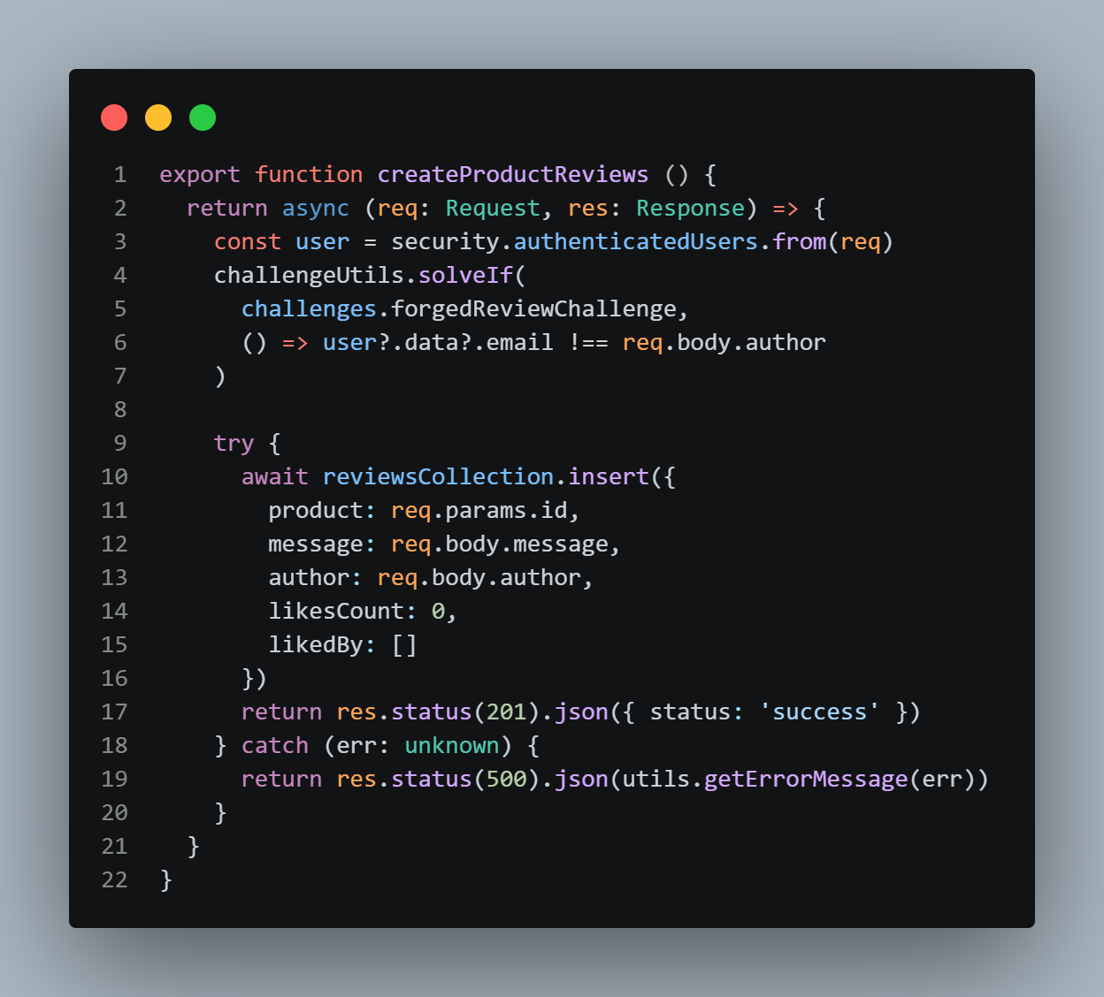
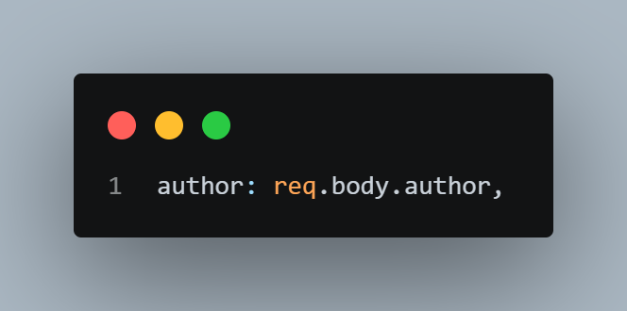
The authenticated user's identity is retrieved (security.authenticatedUsers.from(req)) but discarded for persistence purposes. The author stored in MongoDB is whatever the client sent in the request body.

Exploit: {"message": "Forged review content", "author": "admin@juice-sh.op"}
- Log in as a non-admin user.
- Navigate to any product page and submit a review.
- Intercept the PUT /rest/products/{id}/reviews request with Burp Suite or browser DevTools.
- Observe the JSON body containing {"message": "...", "author": "jim@juice-sh.op"}.
- Changing the author field to VICTIM.
- Forward the modified request
- Refresh the product page. The review now appears under the VICTIM's identity

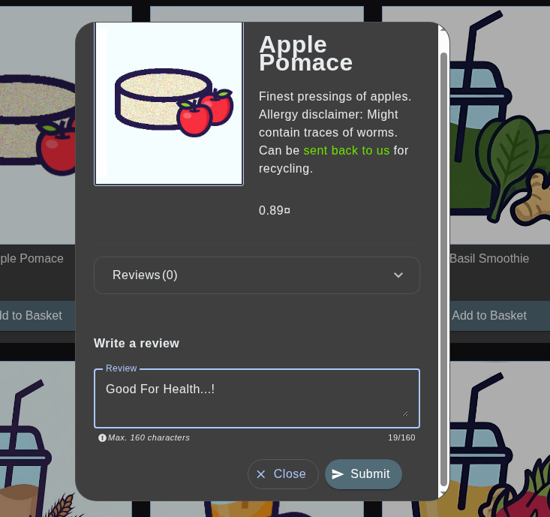
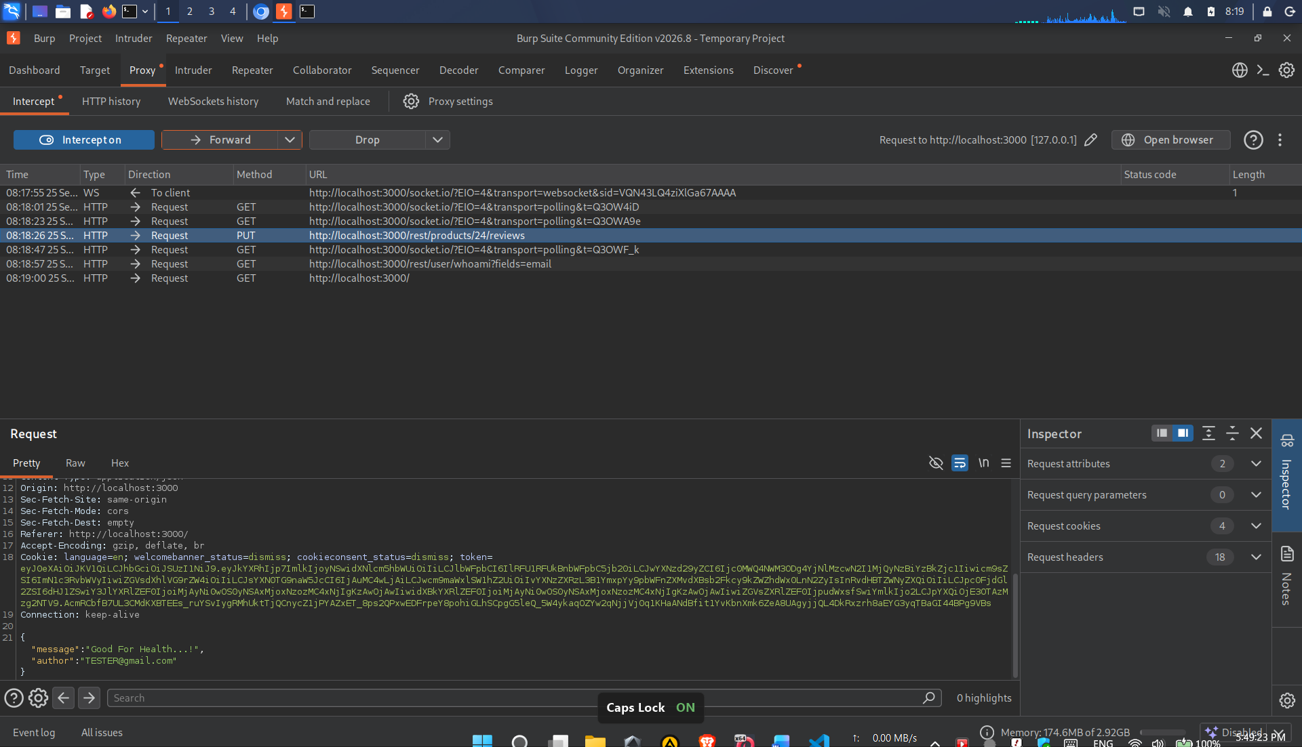

Evidence - Before Fix
- Modify the author’s field to another user's email.
- Forward the tampered request. The server responds with 201 Created and {"status": "success"}, indicating the review was stored without validating the author against the authenticated session.
- Refresh the product page. The review now appears in the product's review list attributed to another user, even though the authenticated session belongs to another user.
- Screenshot showing the intercepted request in Burp Suite with the modified author field, and the product page displaying the forged review under the new user’s identity. Confirming successful impersonation through client-controlled input.

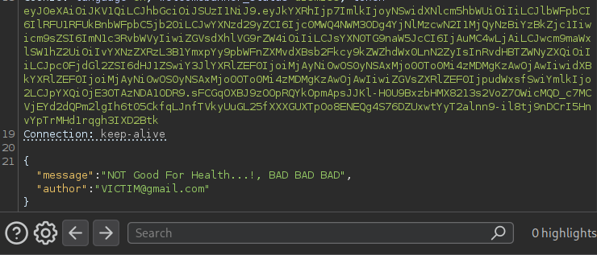
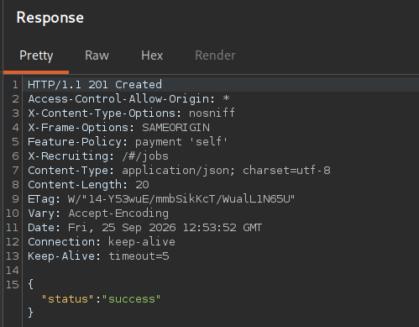
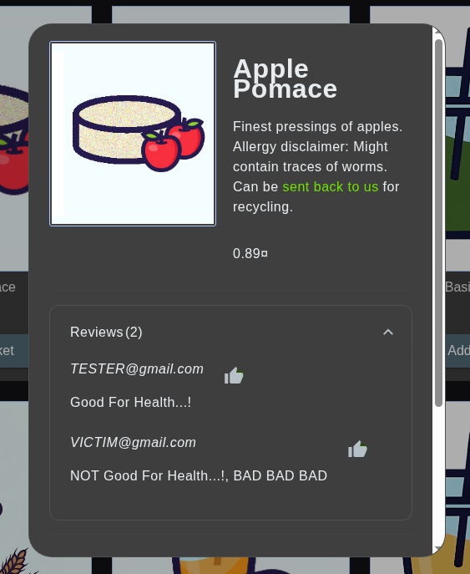
SAST Detection - Before Fix
Tool: Semgrep
Rule: Custom rule targeting req.body.author usage in review handlers
Run against the unmodified routes/createProductReviews.ts, Semgrep flags the interpolated query. Capture the finding count and the specific rule ID and line number flagged.

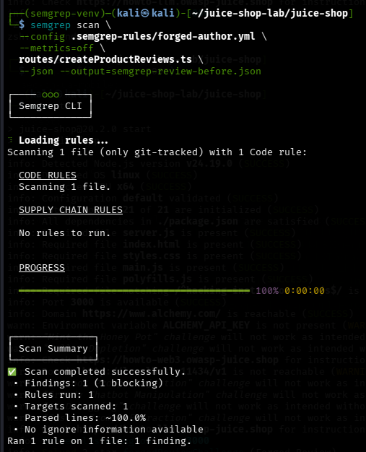
Secure Coding Fix
The server must derive the review's author from the authenticated session, not from client-supplied input. The user object already obtained at the top of the function is the correct source of truth.
if (!user?.data?.email) {
return res.status(401).json({ error: 'Unauthorized' })
}
author: user.data.email,

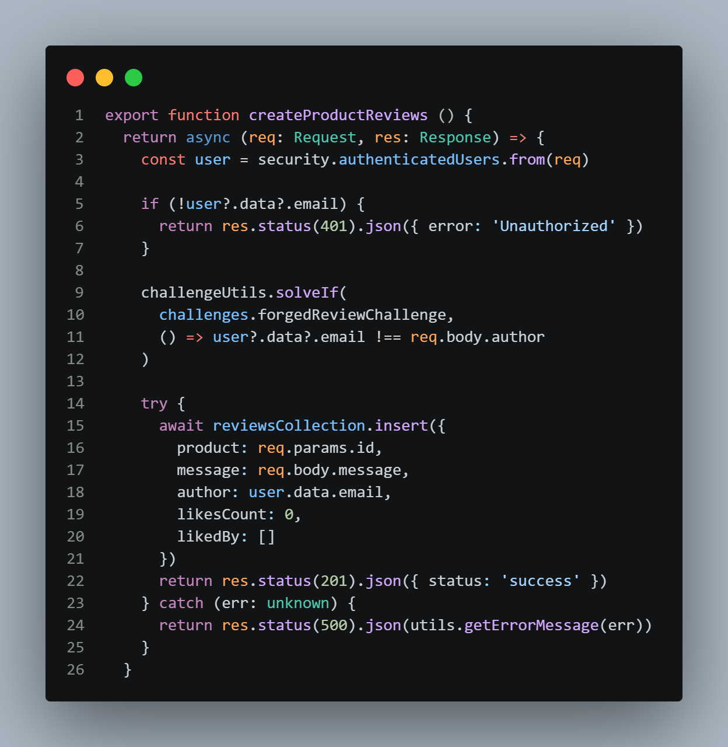
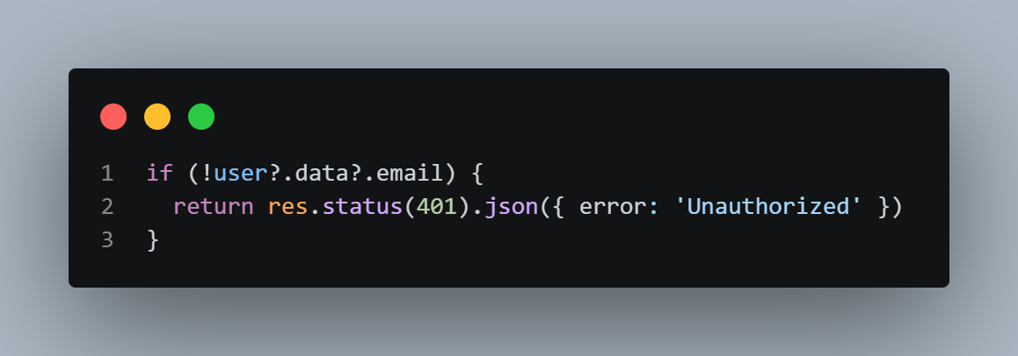
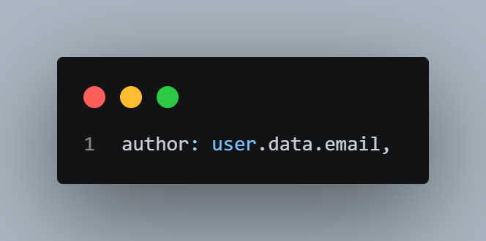

Why this works: The author’s identity is now bound to the server-verified session. Any author’s value in the request body is ignored entirely. An attacker can still send, but the review will be stored under the authenticated user's actual email.
Evidence - After Fix

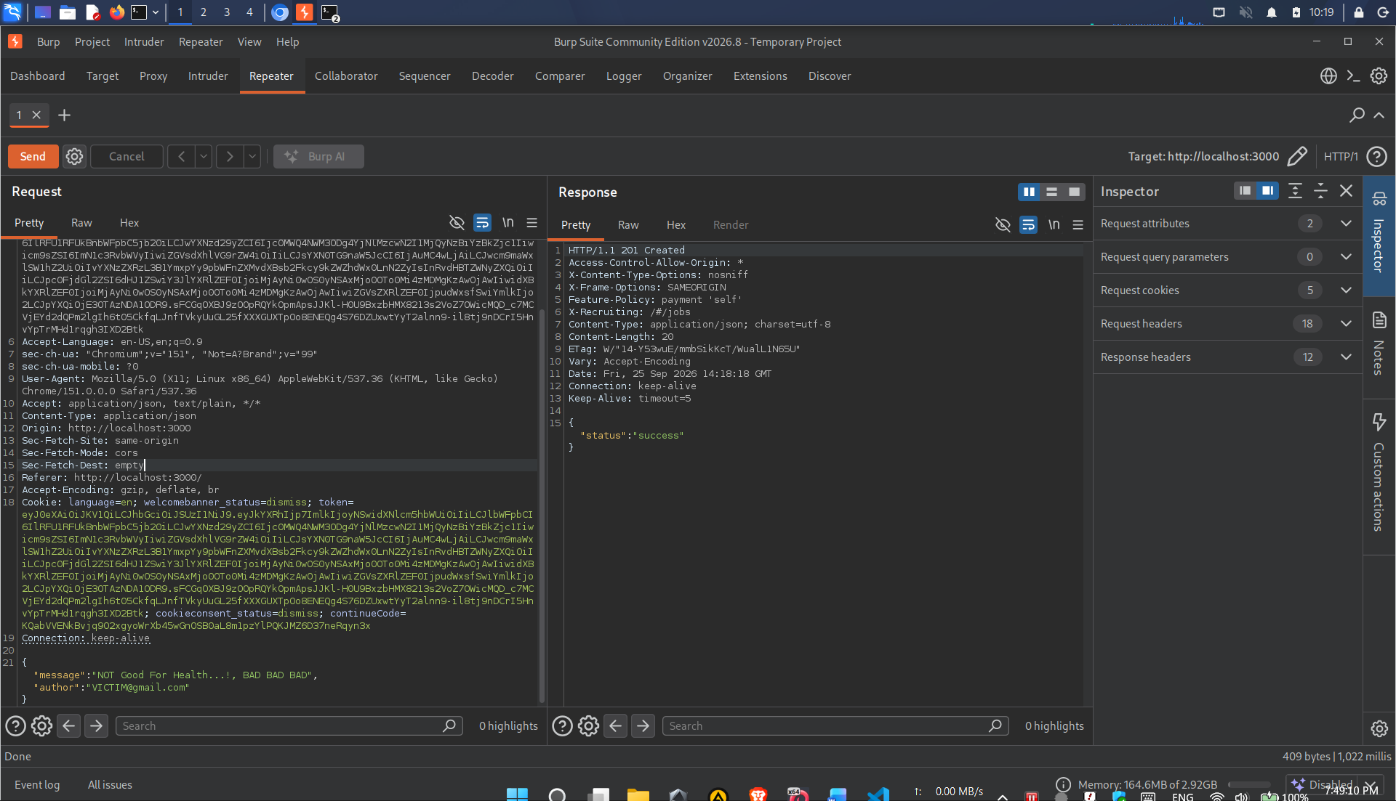
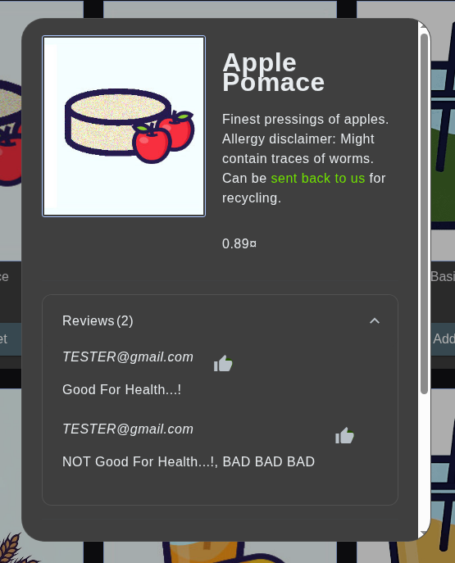

The server returns 401 Unauthorized or ignores the forged author field and stores the review under the authenticated user’s actual identity. The forged review does not appear under forged name.

SAST Detection - After Fix
Re-running the same scan on the patched routes/createProductReviews.ts shows the SQL injection finding is gone.

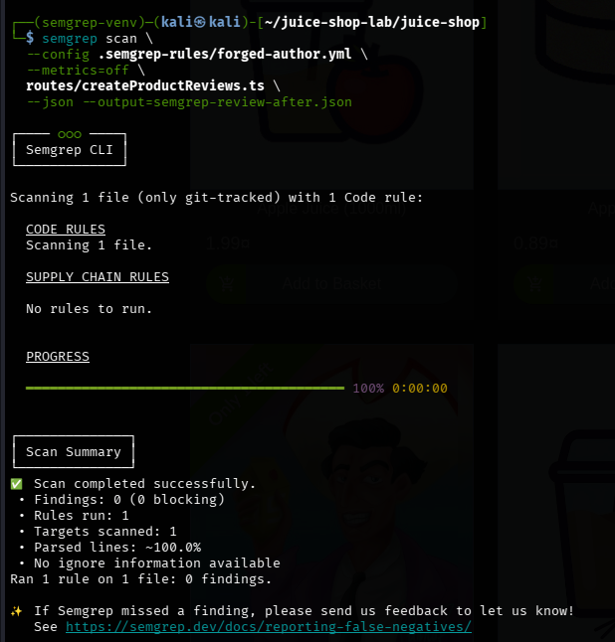

Before / After Summary

Metric | Before Fix | After Fix
Semgrep finding count on createProductReviews.ts | 1 | 0
Forged review as admin@juice-sh.op | Stored successfully | Ignored; stored under real user
Author source | req.body.author (client) | user.data.email (JWT session)
Unauthenticated requests | Accepted (no guard) | Rejected with 401
Root cause present | Yes | No
CWE-284 / CWE-915 compliant | No | Yes

